Creating new guard rail

As of now we are validating format of yml and colang format and it is working for other language too , like if we provide typescripts , java scripts or python the content getting high lighted as per their concern formats

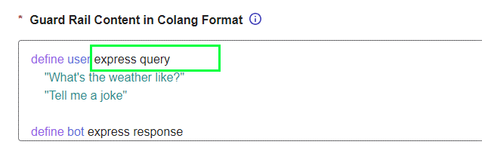

Here the **express query** is not highlighting because format it self there is no solution ,for let’s keep it as it is (suggestion need to develop some internal logic to fix this ) .

The created guard rail should come on top of the table .overall the funtionality working as expected

